Square
Rectangle
Kite
Parallelogram
Rhombus
Trapezium

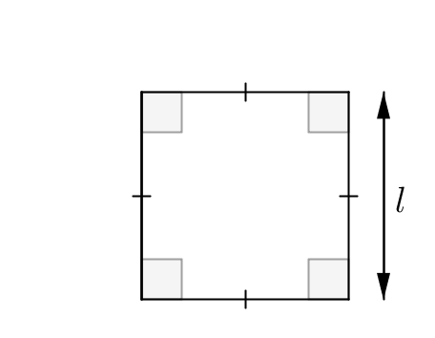  Formula: |   5m
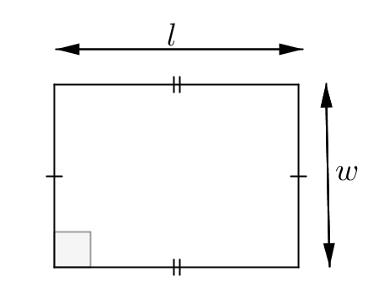  Formula: |   5cm  3cm
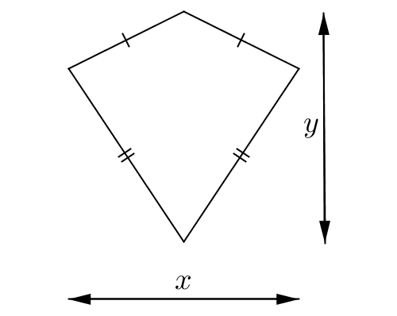  Formula: |   10m  8m
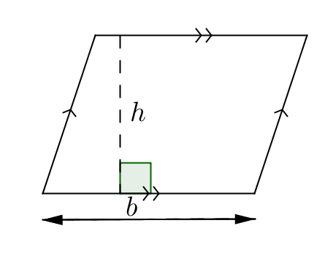  Formula: |   5m  6m
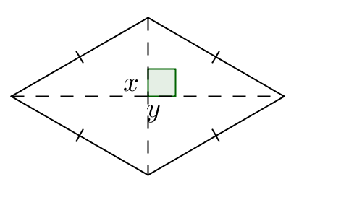  Formula: |   6m  5m
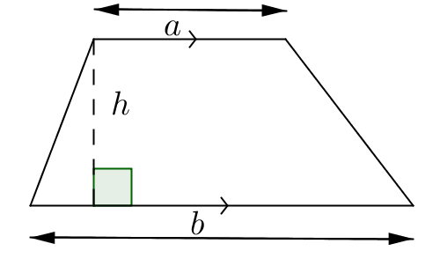  Formula: |   8m  4m  5m

